## Project Development Phase Sprint-3: MIT App Design and Testing

|  |  |
| --- | --- |
| Date | 7 November 2022 |
| PNT2022TMID00922 | PNT2022TMID00922 |
| Project Name | Project – Signs with Smart Connectivity for Better Road Safety |
| Maximum Marks | 8 Marks |

**Wokwi Simulation**: https://wokwi.com/projects/348216301620036179

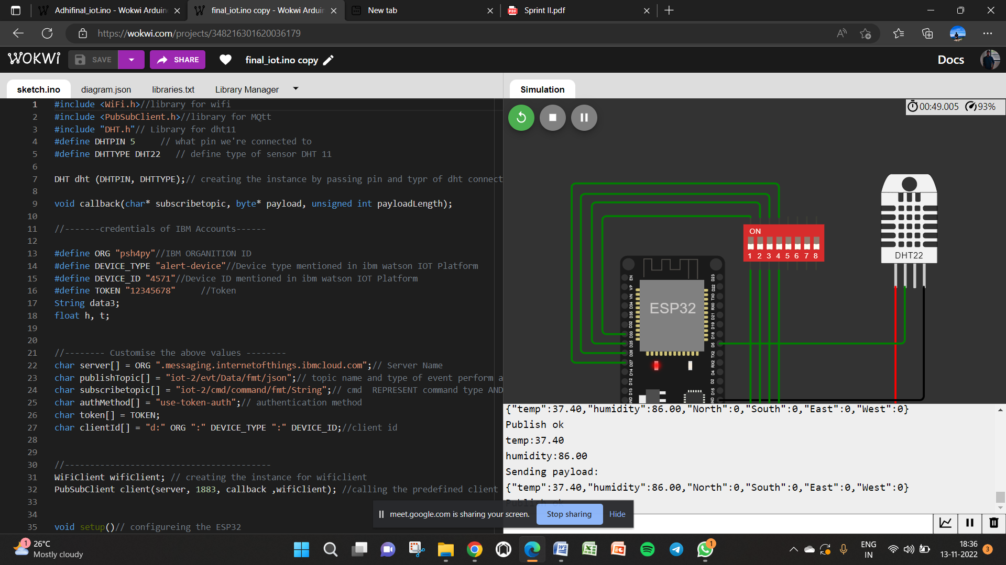

## IoT Device – IoT Platform

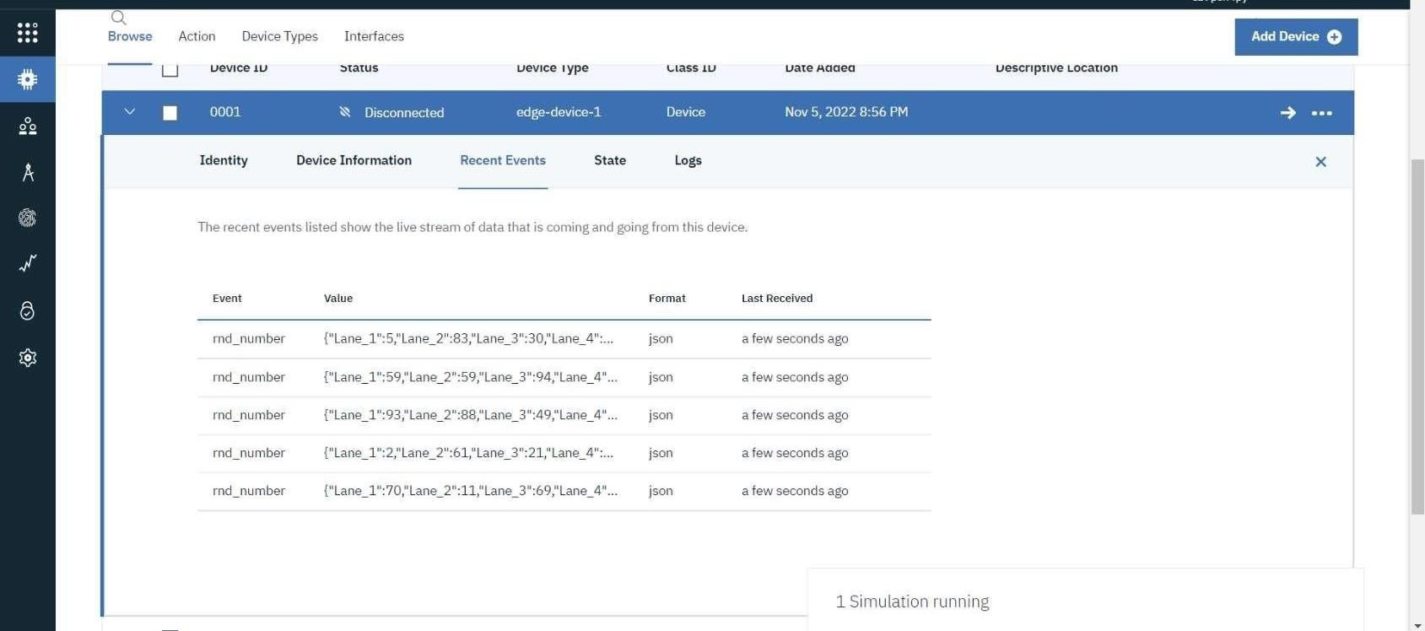

**Node Red – Connect with MIT AppInventor**

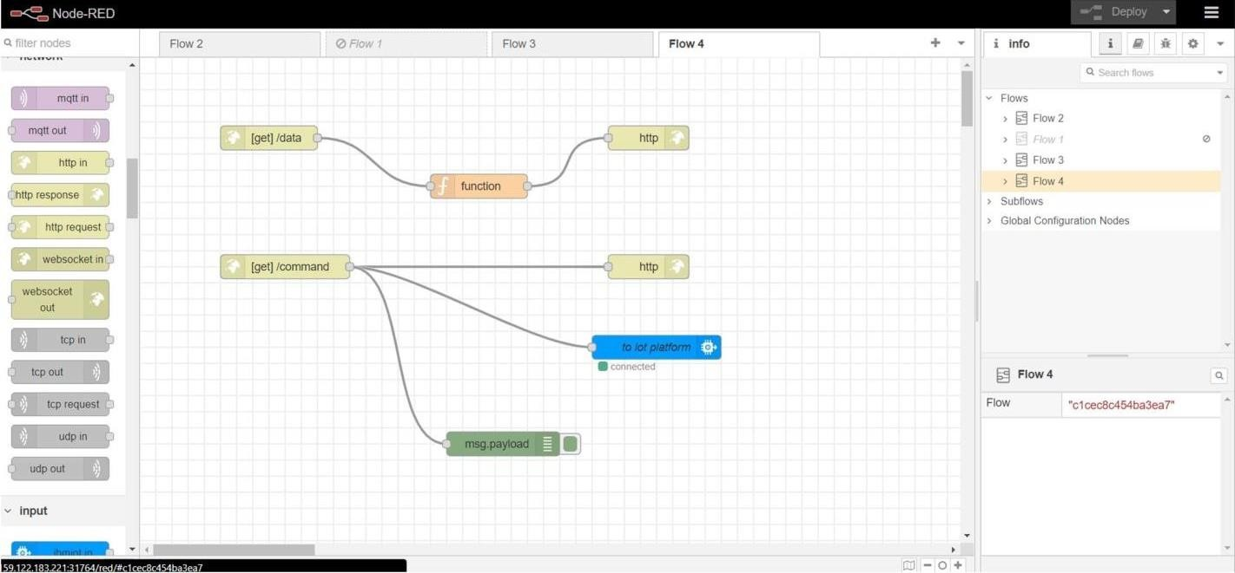

### Edit function node



Delete

O Properties

'g• Name

Cancel





O Setup On Start

### On Message

On Stop

* msg. payload = {

1. "temp" :globa1. get ( "temp" ) ,
2. "humid":global.get(”humid"), p "speed”:global.get(”speed"), s "n" : global . get (”n”),

### "s " : g1obaI . get (”s"),

1. "e ” : global . get ( "e" ) ,
2. "w" : global . get ( "w" ) ,

### g ”res ” : global . get (” res ” ) ,

16 ”11” : gIoba1. get ( ”l1 ”) ,

tt ”12 ” : global . get( ”12 ” )

### 12 "13 " : globa1. get ( "13 "),

13 "14" : gIOba1 . get ( "14" ) ,

t4 "opt imaI I ane" :global . get ( "opt inal Jane" )

15

16’ };

17

ig return msg;

# Output from Node red:

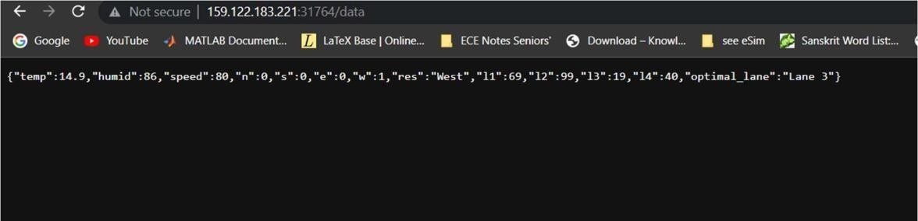

**MIT App Inventor UI design:**

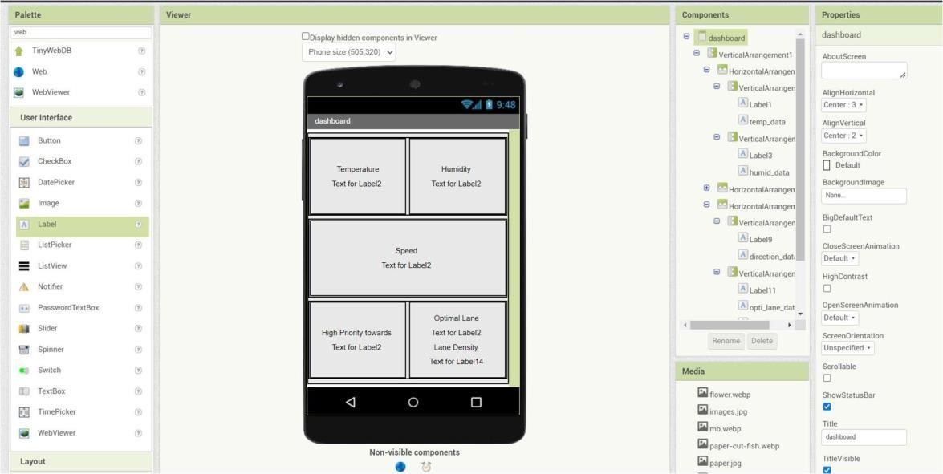

**MIT App Inventor Backend design:**

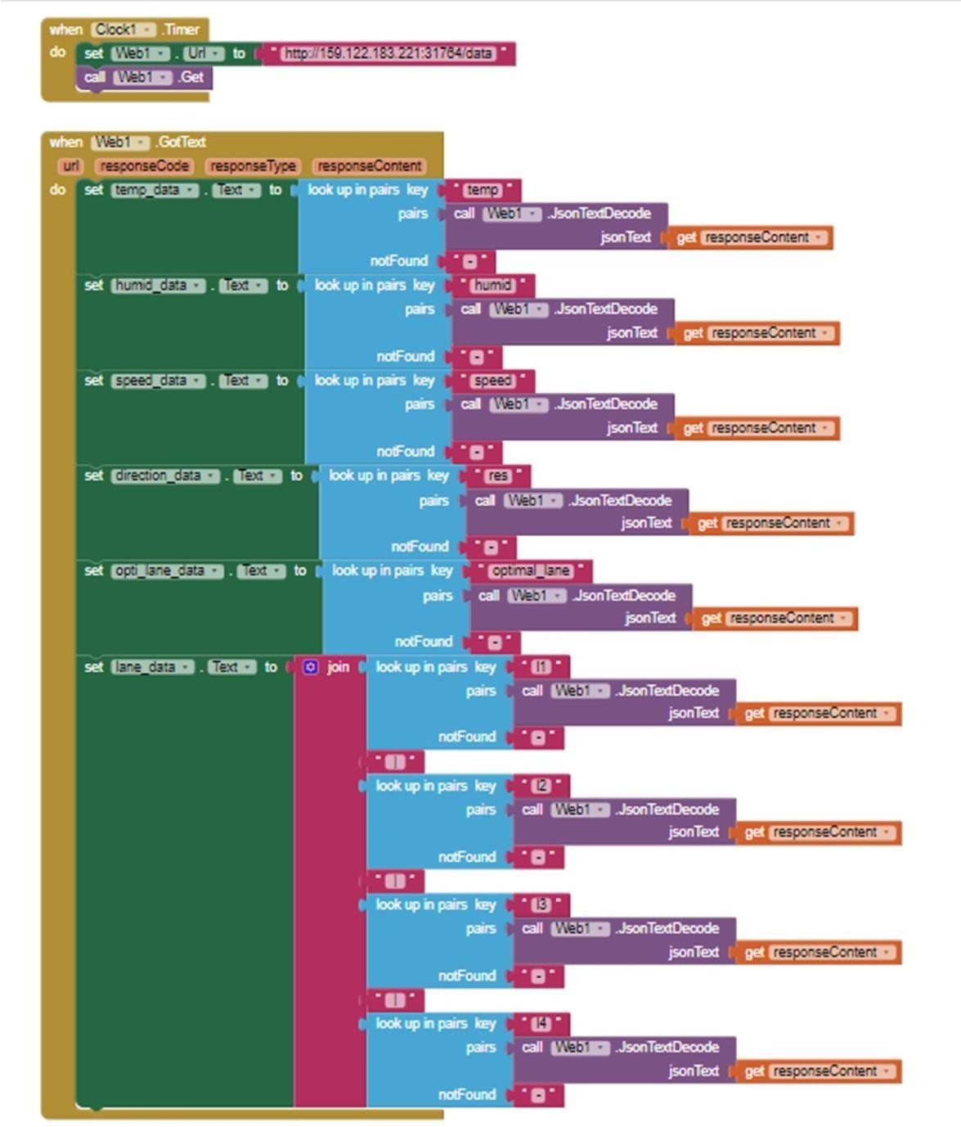

**Sprint 3 delivery:**

**(OUTPUT) Display from MIT App:**

